Spring 2023

Revision History

|  |  |  |  |
| --- | --- | --- | --- |
| Date | Issue | Description | Author |
| February 11, 2023 | Project Phase 1 | Adding Glossary for assignment1 | Group12/005 |
| February 11, 2023 | Project Phase 1 | Adding system actors | Group12/005 |
| February 12, 2023 | Project Phase 1 | Adding Use cases | Group12/005 |
| February 12, 2023 | Project Phase 1 | Use case diagram | Group12/005 |

Table of Contents

IFINANCE System Glossary 4

1.1 Introduction 4

1.2 Glossary 4

IFINANCE System Actors 5

IFINANCE System Use cases 6

IFINANCE System Use case Diagram 7

# IFINANCE System Glossary

## Introduction

This document is used to define terminology specific to the problem domain, explaining terms, which may be unfamiliar to the reader of the use-case descriptions or other project documents. Often, this document can be used as an informal *data dictionary*, capturing data definitions so that use-case descriptions and other project documents can focus on what the system must do with the information.

## Glossary

The glossary contains the working definitions for the key concepts in the IFINANCE System.

|  |  |
| --- | --- |
| Term | Definition |
| Assets | Assets are items that has a monetary value belonged to an individual, business, or organization. Asset includes (but not limited to) cash, land, stocks. |
| Liabilities | Liabilities are individual or company’s financial debts. Few examples of liabilities include items such as inventory cost, loans, mortgages and other types of debt. |
| Expense | An expense is occurred when money is spent from a customer's bank account to pay for goods and services. Few instances of expenses are loan payments, rent, maintenance. |
| Income | Income is defined as an amount of money or other assets generated through time, typically through salary, rent, or investment. |
| Asset account type | An Asset account is a form of financial account to track assets. This includes cash, investments, inventory etc. |
| Liability account type | A liability account is a specific kind of account used by individuals to keep track of their debt obligations to outsiders. This includes student loan, mortgage loan, and other debts. |
| Income account type | Income account type is used to keep a record of the money that comes in from various sources like salary, real estate, stocks. |
| Expense account type | Expense account type is used to keep track of the costs incurred by an individual or organization. Typically, expense accounts are used to keep track of the overall amount of money spent by an individual or organization. |
| Balance Sheet | Balance Sheet is breakdown of the capital, liabilities, and assets of an individual or organization at a specific time, including the balance of revenue and expenses for the preceding period. |
| Profit and loss statement | Profit and loss (P&L) statement provides an overview of the earnings, costs, and expenses incurred over a certain time frame. |
| Cash flow statement | A cash flow statement is a type of financial statement that summarizes all of the cash transactions that have occurred during a specific time period. |
| Debit amount | Debit amount is the amount withdrawn from a bank account by various means such as ATM, a debit card or a check. |
| Credit amount | Credit amount is the total amount of money given to customers through loans. Few examples include mortgage loan, student loan, home loan. |
| Debit account type | A debit account is a form of checking account that allows individuals to make payments and withdraw cash from the account directly. Customers who have debit accounts can use their own funds to pay for goods and services directly from their bank accounts. |
| Credit account type | Credit account type grants credit to a borrower so they can make purchases or take out loans to meet business or individual needs. |
| Double entry book | Double entry book keeping is a method in which each transaction affects two accounts, and always contains both a debit and a credit. |
| Masters account | User can create masters account for each type of accounts such as Income, Expense, Asset, and Liability to manage bank accounts, cash, credit cards. |
| Trial Balance | A trial balance is a report that displays the closing balance of all master accounts in a tabular format and is used in calculating Profit and Loss statement. |
| Closing amount | Closing amount is the entire amount of money present in the accounts of an individual at the end of the day or at the end of specific time period. |

# IFINANCE System Actors

|  |  |
| --- | --- |
| Actors | Roles |
| iFinance User | A general user who interacts with the system. It can be administrator or a normal iFINANCE user. iFINANCE User has the ability to login into the system using user name and encrypted password. They can also change their password. |
| Regular User | A normal user who intends to use iFINANCE system to manage their personal finances, and maintain a record of bank accounts, cash, credit cards, and investment accounts. |
| Administrator | Administrator has the ability to add user accounts into the system. He/She can also edit and delete the profiles of iFINANCE users. |

# IFINANCE System Use cases

|  |  |
| --- | --- |
| Use case Name | Use Case Description |
| Authenticate User | iFinance provides users with a means of logging into the system using a username and an encrypted password. Upon successful login, the system dynamics changes in accordance with the logged-in account's rights. |
| Manage User Accounts | Only the system administrator will have access to add, edit, delete the profile of the users. Note that the system will come with an administrator account. |
| Modify Password | Each user will be able to change their password of iFINANCE system. |
| View Account Categories | iFinance maintains Assets, Liabilities, Income, Expense account categories and Debits, Credits account types. Each category is either Debit type or Credit type. These can be viewed in an interface where the user can drill down the groups to next levels. |
| Manage Custom Groups | Provides a form to user to add, update, or delete Groups. |
| Manage Master Account | This provides an interface to add, update, delete Master Account. Master account includes account Id, account name, opening amount, account group, closing balance and account group of that particular sub group. Closing balance is the closing amount present at that particular point of time and it is updated at transactions. Closed amount will help in showing the closing balances in the statement. This information is used while preparing balance sheet or profit and loss statement where it will sum up the amounts based on the sub groups. |
| Manage Transactions | This provides a tool to manage double entry accounting. Each transaction is either debit or credit type. This tool will allow users to add, update, or delete a transaction’s entry. This also provides a tabular grid which contains the transaction number, date, the total amount of debit and credit, and comments/notes. |
| Generate Reports | iFINANCE generates financial reports such as Trial Balance, Balance Sheet, Profit and Loss statement, and cash flow statement. The Trial Balance is a tabular layout of closing balances of all master accounts. The Profit and Loss statement is obtained by subtracting Expenses from Income. The Balance Sheet shows the Assets and Liabilities plus Profit or Loss in two equal sides. |
| Display Reports | It provides the facility to view all the reports such as Trial Balance, Balance Sheet, Profit and Loss statement and cash flow statements. |
| Print PDF Reports | User can download all the reports such as Trial Balance, Balance Sheet, Profit and Loss statement and cash flow statements in pdf format. The user can print these reports whenever he/she wants. |

# IFINANCE System Use case Diagram

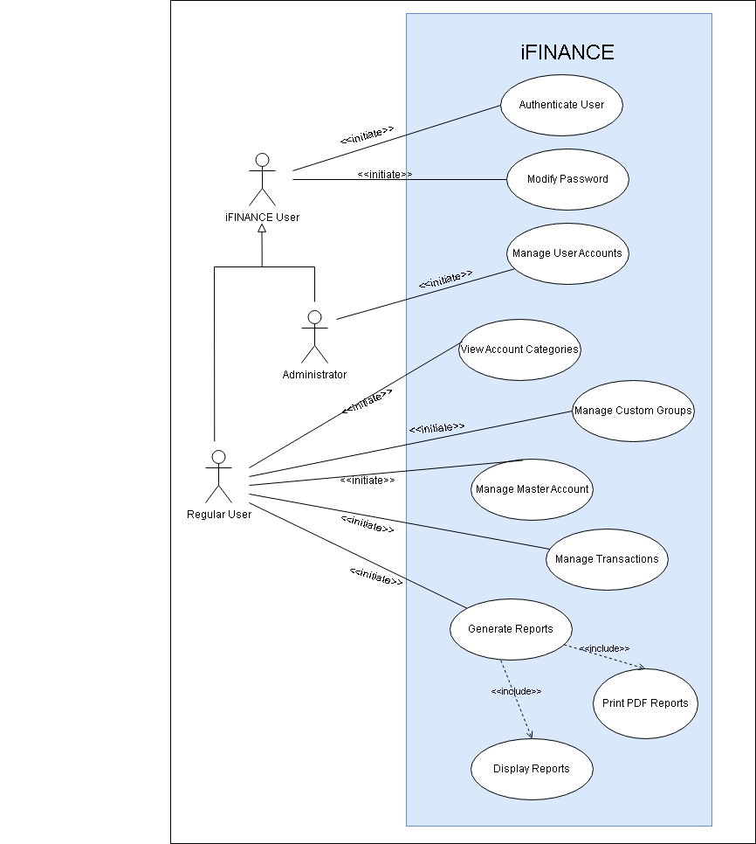

# List of Candidate Classes

|  |  |
| --- | --- |
| Account | Computer screen |
| Asset | Computers |
| Account name | Credit amount |
| Account number | Credits |
| accountGroup | Custom sub-categories |
| accountID | Debit |
| accountName | Desktop Computer |
| Balance Sheet | Date |
| Bank Deposit | Debit amount |
| Businesses | form |
| Cash | Double Entry |
| cash flow statement | Expense |
| Chart of Accounts | Financial reports |
| Credit | Group |
| Credit Card | GroupElement |
| Comments/notes field | groupID |
| groupName | Income |
| GroupParent | Liability |
| iFINANCE Chart of Accounts | Loss |
| iFINANCE Custom Group | Master Account |
| Interest | OpeningAmount |
| Inventory | Master-Detail style form |
| Liability | PDF document format |
| OpeningAmount | Profit |
| Password | Profiles |
| Profit and Loss Statement | Rent |
| Report | Salary |
| Self-employed | System administrator |
| System | Total amount of credit |
| Transaction | Total amount of debit |
| Transaction number | Trial Balance |
| User accounts | Closing Balance |